Savings Survey
December 2011

Conducted by Horizon Research Limited
For the
Financial Services Council

Contents

EXECUTIVE SUMMARY 3
1. KiwiSaver membership 6
2. Perception of savings growth 6
3. Home ownership expectation at retirement 7
4. Retirement income 8
4.1 Who is responsible? 8
4.2 Planning for retirement 9
5. Expected retirement age 10
6. Expected lifespan 11
7. Retirement income requirements 16
7.1 Weekly income required 16
7.2 Income to cover basic costs. 19
7.3 New Zealand Superannuation enough to live comfortably? 19
7.4 Current saving 20
7.5 Retirees - Income 21
7.6 Concern that retirement savings will not last 21
8. Retirement income sources 22
9. Funding New Zealand Superannuation 23
9.1 Ability to afford New Zealand Superannuation 23
9.2 Taxpayer willingness to fund New Zealand Superannuation 28
10. Ability to cover retirement expenses 30
11. Respondent reaction to home refurbishment and vehicle replacement 31
12. Review for retirement income security 32
13. Support for multi-party political discussions on retirement income stability 33
14. Focus groups 33
APPENDIX 1 – SAMPLE 34
APPENDIX 2 – PROFILES 36
APPENDIX 3 – COMPARISON BETWEEN SUPPLIED LONGEVITY TABLES AND SURVEY 41
APPENDIX 4 –QUESTIONNAIRE 42

EXECUTIVE SUMMARY

Three quarters of New Zealanders believe that they are responsible for their income security at retirement. However, less than half of these people believe they are ultimately solely responsible; responsibility is seen as being shared with the Government.

20% think that the Government is solely responsible for their retirement income security, but very few think that their family bears any responsibility.

A challenge for New Zealanders will be to live within their income in retirement: two thirds say they often find it hard to live within their income. A key determinant of how comfortably people can live is whether they have a mortgage or are paying rent. Where people are living in a mortgage-free property or a family trust-owned property they are much more likely to feel that their income will be sufficient.

Just over 60% of people expect to own a mortgage-free dwelling by the time they retire and this expectation is significantly higher among younger people, who also are more likely to feel that New Zealand Superannuation will not be affordable for New Zealand in the future.

A further challenge is to save enough: over 60% do not know how much they will need and 45% are not really planning for retirement at all. Over 60%, however, say they are not saving enough. A majority of retirees say that their current income is less than they expected before retirement, suggesting underestimation of requirements. Planning is made more uncertain because most people tend to underestimate how long they will live.

Most people understand that New Zealand Superannuation will not provide them with enough money to live comfortably, with individuals saying they need around $630 per week and couples $845 per week to live comfortably in retirement. The shortfall for both individuals and couples is around $300 per week.

Planned or current retirement income is generally from a mix of two to three sources, the most important being New Zealand Superannuation, KiwiSaver and savings (other than superannuation schemes). Note that KiwiSaver is not seen as sufficient on its own.

Men are generally more optimistic about their retirement income level than women and are generally less worried about whether their retirement savings will last to the end of their lives.

New Zealanders are generally aware that New Zealand Superannuation may not be affordable in the future, but there is an even split over whether taxpayers would fund it if it were still available in future with an eligibility age of 65 years. As they see the government as a key player in providing one of their retirement income sources. They are definitely interested in a review of policy and in multi-party political discussions aimed at achieving retirement income stability.

Key findings:

KiwiSaver membership:
- 50% of respondents said that they were KiwiSaver members
- Two-thirds of households surveyed have a KiwiSaver member.
- In two-thirds of the households where the respondent was a member, there was also another KiwiSaver member in the household

Perception of savings growth
- Most respondents were unable to correctly give the length of time it would take for a deposit to double its value. More than half of respondents selected a time span less than the accurate one, suggesting general underestimation of investment growth.
- Respondents who were aged 25-44 years tended to have the lowest expected time for a deposit to double its value.

Home ownership expectation at retirement
- 10.5% of respondents were already retired and owned a mortgage –free dwelling.
- A further 49.6% expect to do so by the time they retire. This expectation is strongest amongst younger people.

Retirement income
- 76% of respondents believed that they were personally responsible for their income security in retirement. 31% feel that they are solely responsible for their retirement income.
- 61.2% of respondents believe that the Government is responsible for their retirement income security.
- Very few feel that their family has responsibility for their retirement income.
- 65.1% say that they find it difficult to live within their income.
- There is low belief in New Zealander Superannuation covering retirement income needs.

Expected retirement age and lifespan:
- The average expected retirement age is 67.6 years.
- The largest group of respondents – nearly 30% - expected to retire at 65 years of age
- Female respondents expected to retire earlier than male respondents; the average expected age for women is 67.1 years and for men it is 68.7 years.
- KiwiSaver members expect to retire earlier (67.0 years of age, on average) than people who are not KiwiSaver members (68.5 years on average).
- Average expected lifespan is 83.5 years.

Weekly income requirements:
- Average needed income for an individual was $632 per week (equivalent to $38,650 per annum before tax).
- Average needed income for a couple was $845 per week (equivalent to $25,442 each per annum before tax).
- One-third of respondents feel that they would have enough retirement income to cover basic costs (food, accommodation and health care).
- Only 10.1% believe that a government pension like New Zealand Superannuation would be enough by itself to live comfortably.
- 62.9% of respondents said that they were not currently saving enough to retire on a comfortable income.
- Retirees who are in their own dwelling without a mortgage, or who live in a dwelling owned by a family trust are more likely to say that their income is adequate.
- 61.5% of retirees say that their income is not as much as they expected before retirement.
- Nearly 80% of respondents had some concern that their savings would run out before the end of their lives.

Income sources:
- Overall, 26.9% of respondents indicated that they would only have, or currently had, one source of income in retirement.
- New Zealand Superannuation, KiwiSaver and savings were the most important retirement income sources.
- Only 7.3% of respondents think that KiwiSaver would be their sole source of income

New Zealand Superannuation funding:
- 58.4% of respondents believed that New Zealand could not continue to afford New Zealand Superannuation if eligibility started at 65 years.
- Opinion is split on whether taxpayers would be willing to continue to pay for New Zealand Superannuation into the future if eligibility started at 65 years.
- Only 7.3% of respondents think that KiwiSaver would their sole source of income

Adequacy of retirement income:
- A majority do not think that their retirement plan will fund house refurbishment, three car replacements and overseas holidays.
- Most people are surprised at the idea that they may need to replace their car three times and refurbish their dwelling during their retirement.

REPORT

KiwiSaver membership
Half (50.1%) of the respondents said that they were members of KiwiSaver.This survey suggests that in December 2011 1,612,000 New Zealanders 18+ were KiwiSaver members. This compares with official statistics that show 1,534,789 members aged 18+ in November 2011with a growth rate of approximately 25,000 per month.

Where the respondent was not a member (49.9% of respondents), there was said to be a KiwiSaver member in the household in 36.1% of cases. The survey therefore suggests that there is at least one KiwiSaver member in two-thirds of the households surveyed.

Note that in two-thirds of the households where the respondent was a member, there was also another KiwiSaver member in the household.

Someone else in household a member of KiwiSaver | Total | KiwiSaver member
 |  | Yes | No
Yes | 52.7% | 67.9% | 36.1%
No | 37.3% | 23.2% | 50.8%
I really don't know | 10.1% | 7.9% | 12.2%

76% of KiwiSaver members are in full-time or part-time employment, compared with 51.9% of people who are not KiwiSaver members.

Perception of savings growth
Respondents were asked how long they thought it would take for a $1000 bank deposit earning 3% to double. Only 13.4% had the correct answer of between 24 and 25 years.

On average, respondents thought that it would take 19.5 years. Nearly a quarter of them thought that it would only take 10 years; these people are primarily aged 25 to 54.

A further 25% thought that it would take 30 years

No. years | Total
10 years | 23.0%
11 years | 1.1%
12 years | 4.0%
14 years | 1.7%
15 years | 7.3%
16 years | 0.9%
17 years | 0.9%
18 years | 0.6%
19 years | 0.8%
20 years | 12.4%
21 years | 1.0%
22 years | 1.7%
23 years | 2.7%
24 years | 6.0%
25 years | 7.4%
26 years | 0.6%
27 years | 0.8%
28 years | 0.7%
29 years | 1.6%
30 years | 24.8%
Total | 100.0%

Home ownership expectation at retirement
Expectation of owning a dwelling without a mortgage by retirement is high, with 10.5% of respondents saying that they were already retired and owned a dwelling without a mortgage and a further 49.6% overall expecting to do so by the time they retired.

This expectation was significantly higher amongst younger people, declining with increasing age. Note that at 65 years of age the expectation level crosses over with the level of those who were already retired and have a dwelling without a mortgage.

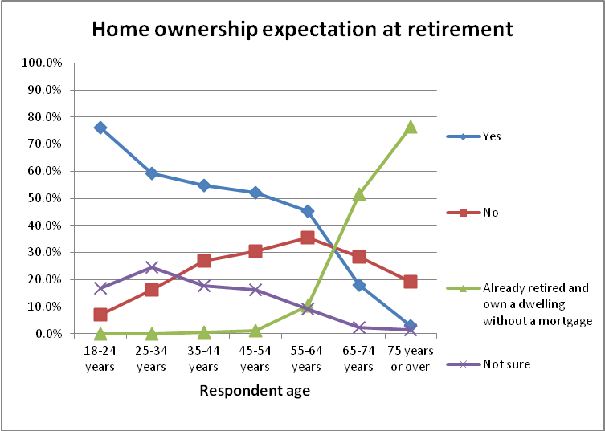

Only 2.5% of those who already own a dwelling without a mortgage do not expect to be in their own dwelling without a mortgage at retirement.

Retirement income

Respondents were given a series of statements covering their retirement income and asked to indicate how strongly they agreed or disagreed with each statement. Overall, only 31.6% of respondents believed that they were solely responsible for their income security in retirement.

Who is responsible?
The chart below shows that 76% of respondents believed that they were personally responsible for their income security in retirement. 61.2% of respondents believe that the Government is responsible for their retirement income security. This perception is largely held in conjunction with personal responsibility (see below).

There is a very strong view from respondents that their family is not responsible for their income security in retirement; only 10.6% felt that their family had some responsibility.

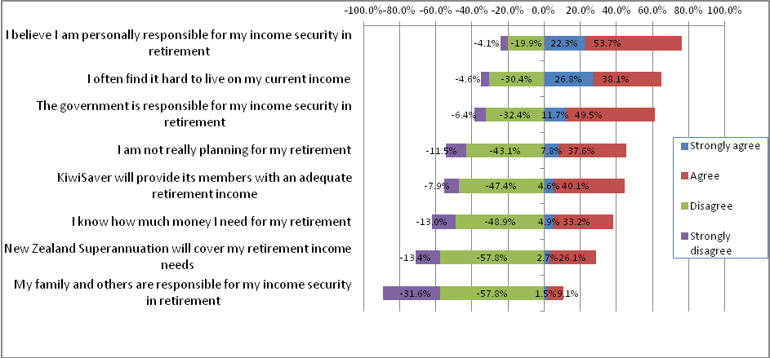

Nearly one-third of respondents felt that they were solely responsible for their income security in retirement. Just fewer than 20% felt that it was solely the Government’s responsibility. As noted above there is a very strong view from respondents that their family is not responsible and this is shown by the minimal 0.2% who felt that their family was solely responsible.

Solely personal responsibility | 32.3%
Solely Government responsibility | 19.6%
Solely family responsibility | 0.2%
Personal plus Government responsibility but not family | 35.0%
Personal and family responsibility but not Government | 3.9%
Government and family responsibility but not personal | 1.8%
Personal and Government and Family responsibility | 4.5%
Not sure who is responsible | 2.8%

Profiling the group who say they are solely responsible indicates that they:
- are aged 18 to 54
- are more likely to be employed
- have average income 13% higher than the total sample

A copy of the profile of this group supplied in December 2011 is included in Appendix 2.

4.2 Planning for retirement
65.1% of respondents agreed that they often found it hard to live within their income. Respondents who were the most likely to agree with this were not in paid employment. However, it did have majority agreement across all gender, age and employed/not employed/retired groupings – for example, 60% of those who were working fulltime still agreed with this statement. Only where household or personal income exceeded $100,000 per annum did a majority disagree with the statement. KiwiSaver members were more likely to agree with this statement than non-members.

61.8% of respondents said that they did not know how much money they needed for their retirement. Only those who were currently retired felt that they did know how much money they needed: 71% of them agreed with the statement.

45% of respondents agreed that they were not really planning for their retirement. The figure is even higher – 59.7% - for those who are not in paid employment but are not retired. 68.9% of those who are already retired say that they are planning for their retirement.

Despite the relatively high proportion of respondents who had KiwiSaver, only 50% of KiwiSaver members felt that it would provide its members with an adequate retirement income.60.3% of those who do not have KiwiSaver do not believe that it will provide an adequate retirement income. Respondents who are not in paid employment (but not retired) and those who are already retired and 65 years of age or over are more likely to believe in KiwiSaver than other groups.

Belief in New Zealander Superannuation covering retirement income needs is low; only 29% agreed that it will. Those who are currently employed fulltime are less likely to feel that New Zealand Superannuation will cover their needs, as are KiwiSaver members. The only group where a majority feels that New Zealand Superannuation will cover their needs consists of people under 65 years of age who are already retired.

Expected retirement age

7% of respondents said that they expected to retire at 60 years of age, but the largest group of nearly 30% of respondents said that they expected to retire at 65 years of age.10% expect to retire at 67 years of age, 23% at 70 years and 7% at 75 years. The following chart shows that female respondents expected to retire earlier than male respondents; the average expected age for women is 67.1 years and for men it is 68.7 years. Similarly, KiwiSaver members expect to retire earlier(67.0 years of age, on average) than people who are not KiwiSaver members (68.5 years on average).

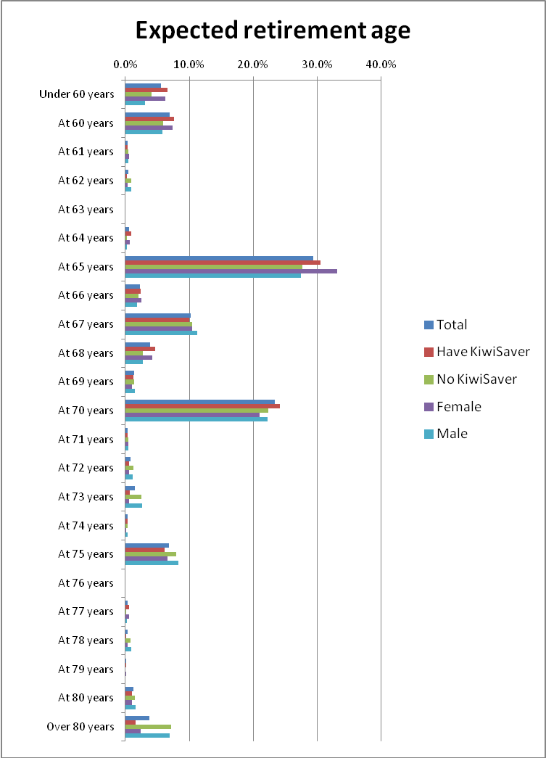

Expected lifespan

Respondents were asked to give an expectation of the age they would you live to, given that they attained the age of 65 years or were already 65 years of age or older. Respondents expected to live, on average, to 83.5 years of age.

18 to 24 year olds in the sample expected to live 3% longer, to an average of 85.8 years, and those respondents who were already 75 years of age or more expected to live to an average of 88 years.

Respondents were then given 4 categories – Maori men, Maori women, non-Maori men and non-Maori women – and asked how long they expected people in each category to live. There was an immediate difference from their self-expectation; overall, people in these categories were expected to live to an average of 77.4 years, 7.3% less than the overall self-expectation.

The ages to which people expected people in these categories to live are shown in the chart below. Average ages for the four categories are:

- Maori men: 71.4 years
- Maori women: 74.6 years
- Non-Maori men: 79.7 years
- Non-Maori women: 84.0 years

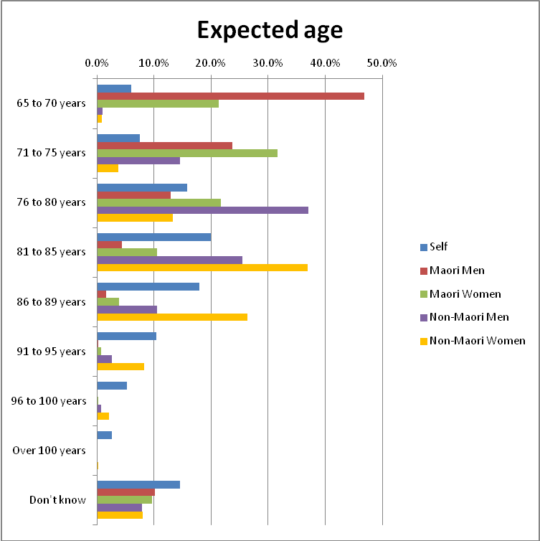

FSC provided tables of life expectancy for comparison with respondents’ perceptions. The comparison indicates that the population generally lives longer than people expect:

- Maori men by 10%
- Maori women by 9%
- Non-Maori men by 4%
- Non-Maori women by 2%

The figures on how long respondents expected each of these groupings to live were compared with the table data supplied by FSC and comparison graphs constructed. The survey uses age groups after age 65 and the FSC data was recast into those groups. The comparison graphs show the percentage of people still alive after attaining 65 years in age groupings and are attached in Appendix 3. There is good relatively good alignment between the survey and the tables in the non-Maori groupings. However, the survey results for Maori men and women show a marked discrepancy from the tables.

Younger people expect to live longer, as shown in the following table:

 | Total | Age Group
Expect to live to: |  | Under 18 years | 18-24 years | 25-34 years | 35-44 years | 45-54 years | 55-64 years | 65-74 years | 75 years or over
65 to 70 years | 6.0% | 0.0% | 4.0% | 10.3% | 4.6% | 8.2% | 5.0% | 1.2% | 0.0%
71 to 75 years | 7.5% | 0.0% | 2.6% | 9.8% | 10.1% | 6.8% | 9.3% | 4.9% | 2.4%
76 to 80 years | 15.8% | 0.0% | 10.3% | 9.9% | 12.6% | 21.4% | 17.8% | 23.1% | 5.8%
81 to 85 years | 19.8% | 0.0% | 17.7% | 13.8% | 19.6% | 22.4% | 21.3% | 25.0% | 19.4%
86 to 89 years | 18.2% | 14.8% | 26.9% | 18.1% | 17.7% | 13.8% | 16.2% | 19.9% | 32.9%
91 to 95 years | 10.3% | 24.9% | 14.2% | 9.1% | 7.9% | 8.6% | 11.5% | 11.8% | 17.6%
96 to 100 years | 5.4% | 9.1% | 4.8% | 5.2% | 7.2% | 5.2% | 3.8% | 3.9% | 13.9%
Over 100 years | 2.6% | 0.0% | 3.2% | 4.6% | 2.6% | 0.8% | 3.5% | 1.8% | 0.5%
Don't know | 14.5% | 51.2% | 16.4% | 19.1% | 17.8% | 12.7% | 11.6% | 8.4% | 7.5%
Avg expected age | 83.5 | 91.9 | 85.8 | 83.1 | 83.6 | 81.9 | 83.2 | 83.9 | 88.0

FSC supplied longevity projections which had been provided to FSC by PricewaterhouseCoopers. The projections were based on a number of sources, including “Aging Populations: The challenges ahead’ (Lancet 2009). The Lancet population projects were used for a very low mortality projection and show that half of people born now will live to age 100. These figures were contrasted with respondents’ self-perception of the age to which they would live. By analysing by current age, figures based on grouped retirement year and showing expected age of death were produced. These are charted against the Lancet-based projections as shown below:

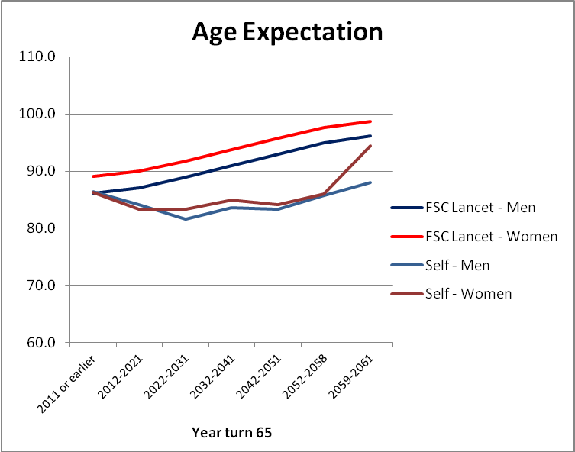

This demonstrates an 8% to 10% gap for males between the Lancet projections and respondent expectation and a 9% to 12% gap for females; i.e. respondents are significantly underestimating the age to which they may live.

The gap is shown in the table in the following table:

 | Expected Lifespan (years)
Year of retirement | Lancet |  | Self-expectation |  | % Gap
 | Male | Female | Male | Female | Male | Female
2011 | 86.1 | 89.1 | 86.5 | 86.3 | -0.4% | 3.2%
2012-2021 | 87.1 | 90.0 | 84.1 | 83.4 | 3.4% | 7.4%
2022-2031 | 88.9 | 91.8 | 81.6 | 83.3 | 8.3% | 9.3%
2032-2041 | 90.9 | 93.7 | 83.6 | 84.9 | 8.0% | 9.4%
2042-2051 | 93.0 | 95.7 | 83.4 | 84.1 | 10.3% | 12.1%
2052-2058 | 94.9 | 97.6 | 85.8 | 86.0 | 9.6% | 11.9%
2059-2061 | 96.1 | 98.7 | 88.0 | 94.4 | 8.4% | 4.4%

Changes in lifespan
Respondents were told that every 10 years, the number of people in New Zealand living to be older than 65 years rises. They were asked how much longer they thought people born in 2006 could expect to live than people who were born in 1996.

Although 17% of respondents did not feel confident to give an opinion, there was an expected increase of 3.3 years on average for men and 3.7 years, on average, for women. Note that nearly a quarter of respondents felt that women born in 2006 would live for an additional 5 years in comparison with those born in 1996.
Expected increase in lifespan | Men | Women
0.5 year | 4.7% | 3.9%
1 year | 7.1% | 4.9%
1.5 years | 5.2% | 3.7%
2 years | 9.1% | 6.3%
2.5 years | 6.8% | 5.4%
3 years | 10.3% | 8.7%
3.5 years | 3.8% | 4.4%
4 years | 5.6% | 7.1%
4.5 years | 2.3% | 3.6%
5 years | 11.0% | 10.5%
More than 5 years | 16.8% | 23.4%
Not sure | 17.3% | 17.9%
Average (years) | 3.3 | 3.7

Respondents were also asked to give their opinion on what age New Zealanders who turn 65 years old in the year 2061 will eventually live to. There is clearly an expectation that those people will live longer than people currently aged 65; in general,there was a 3 to 5 year increase in expected age for people turning 65 in 2061.

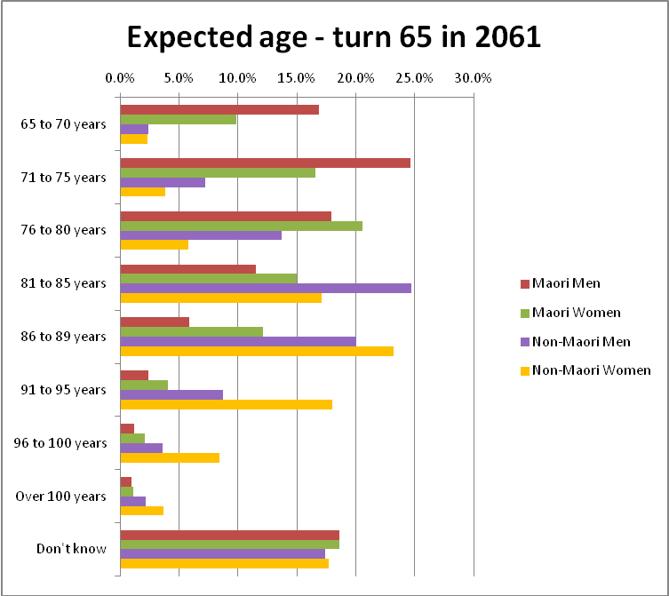

Perceived average increases in lifespan differ for the four groups measured:

Group | Future average | Current average | Change
Maori Men | 76.4 | 71.4 | 5.0
Maori Women | 79.3 | 74.6 | 4.7
Non-Maori Men | 83.8 | 79.7 | 4.1
Non-Maori Women | 87.3 | 84.0 | 3.3

Retirement income requirements

7.1 Weekly income required
Respondents were asked what level of weekly income after tax they thought a couple and an individual would need to live comfortably in retirement. Respondents were not given a definition of “live comfortably”; they were able to self-define this.

Individuals were thought to need, on average, around $632 per week (equivalent to $38,650 per annum before tax). By comparison, an individual on New Zealand Superannuation can currently expect to receive $339.92 after tax per week, leaving a shortfall of $292 per week to meet the survey result average for an individual to “live comfortably”.

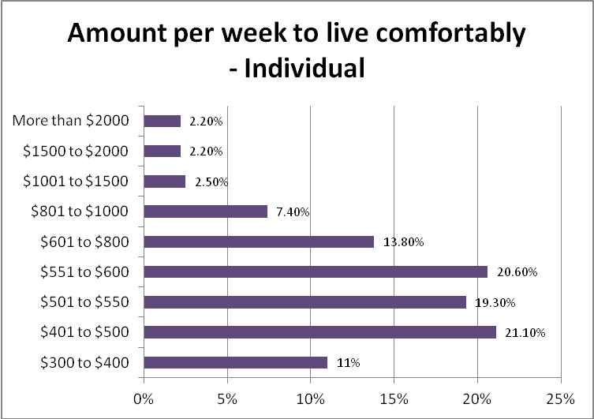

Couples were thought to need, on average, $845 per week after tax (equivalent to $25,442 each per annum before tax). New Zealand Superannuation currently provides a couple who both qualify with $522.96 after tax per week between them, leaving a shortfall of $322 per week to meet the survey result average for a couple to “live comfortably”.

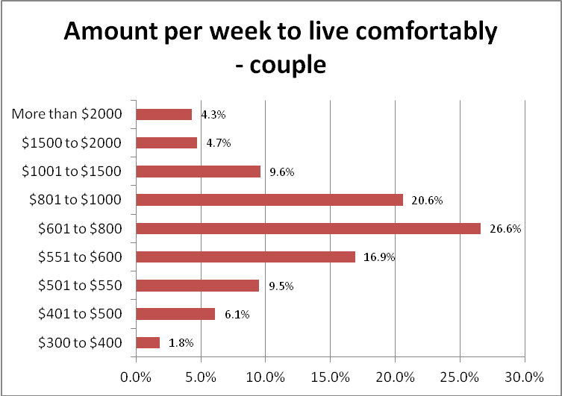

Evaluating the amount by needed by current dwelling ownership shows some differences from the average as shown below. Where people currently own a dwelling without a mortgage (a high proportion of these people are already retired, and people who are currently retired appear to feel that they need a lower weekly income), are in a dwelling owned by a family trust or are flatting/boarding, their perceived average weekly income need is lower.

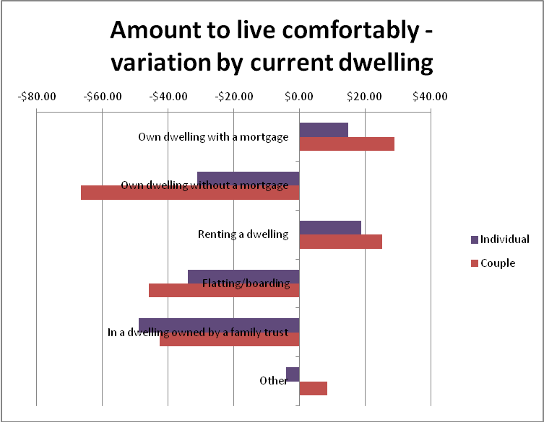

Similarly, people who expect to own a dwelling without a mortgage by the time they retire perceive that couples and individuals will require an average weekly income around 3.5% above the average for all respondents.

People in single-person households or in single parent households with 3 or more children tend to believe that couples and individuals need less than the average figure to live comfortably. The following table shows the averages by current household type.

Household type | Average per week
 | Couple | Individual
Couple only (no children/none at home) | $825.38 | $670.30
Extended family | $862.58 | $637.90
Flatting or boarding - not a family home | $859.10 | $622.00
One parent family, one or two children at home | $877.13 | $685.85
One parent family, three or more children at home | $691.15 | $483.53
Single person household | $797.80 | $575.13
Two parent family, one or two children at home | $870.90 | $637.43
Two parent family, three or more children at home | $898.35 | $624.25
Prefer not to say | $894.33 | $676.90
All interviews | $844.95 | $632.38

7.2 Income to cover basic costs.
Overall, opinion was evenly split on whether respondent s would have enough income in retirement to cover their basic costs for food, accommodation and health: 34% thought that they would, 31.4% thought that they would not, and 34.6% did not know.

There were some marked differences in opinion between respondents with differing accommodation arrangements. Those in a dwelling owned by a family trust or in their own dwelling without a mortgage were much more likely to believe that they would have enough money in retirement for basic costs. Those who were renting were far less likely to believe that.

Enough income to meet basic costs | Total | Own dwelling with a mortgage | Own dwelling without a mortgage | Renting a dwelling | Flatting/ boarding | In a dwelling owned by a family trust | Other
Yes | 34.0% | 33.1% | 53.4% | 20.5% | 30.6% | 45.1% | 42.1%
No | 31.4% | 31.2% | 22.5% | 40.8% | 29.5% | 27.0% | 18.4%
Don't know | 34.6% | 35.8% | 24.2% | 38.7% | 39.9% | 27.8% | 39.5%

Males, people under 34 years of age, people with personal income over $70,000, couples with no children or none at home, people with degrees and KiwiSaver members were other groups that were more likely to believe that they would have sufficient income for basic costs.

7.3 New Zealand Superannuation enough to live comfortably?
Only 10.1% believed that a government pension like New Zealand Superannuation would be enough by itself to live comfortably. This belief is also reflected in the response to the question on retirement income sources later in this section of the report. Those who were currently flatting or boarding, however, were significantly more likely to believe that it would be sufficient.

Able to live comfortably on New Zealand Superannuation only | Total | Own dwelling with a mortgage | Own dwelling without a mortgage | Renting a dwelling | Flatting/ boarding | In a dwelling owned by a family trust | Other
Yes | 10.1% | 6.4% | 11.4% | 7.9% | 23.8% | 11.5% | 17.9%
No | 75.9% | 81.2% | 82.5% | 74.2% | 55.6% | 80.9% | 51.0%
Don't know | 14.0% | 12.4% | 6.1% | 17.9% | 20.6% | 7.6% | 31.2%

KiwiSaver members were less likely than non-members to believe that New Zealand Superannuation would be sufficient.

7.4 Current saving

Only 20% of respondents felt that they were currently saving enough to retire on a comfortable income. Those who currently own a house without a mortgage were the most likely to feel that they were saving enough, but it was still a minority view in that group.

Currently saving enough to retire on a comfortable income | Total | Own dwelling with a mortgage | Own dwelling without a mortgage | Renting a dwelling | Flatting/ boarding | In a dwelling owned by a family trust | Other
Yes | 20.0% | 18.1% | 38.8% | 10.5% | 21.9% | 22.0% | 2.5%
No | 62.9% | 65.5% | 43.7% | 75.0% | 57.4% | 58.3% | 66.4%
Don't know | 17.2% | 16.5% | 17.6% | 14.4% | 20.7% | 19.8% | 31.2%

Those who thought that they were currently saving enough were much more likely to be:
- male rather than female: generally, males were more optimistic than females about retirement income and savings throughout this study.
- aged 25-34 years or 65-74 years
- with household income over $50,000 per annum
- with personal income over $30,000 per annum
- employed
- working in a senior role
- already retired
- in a household with a couple only (no children or none at home), or a single person household

7.5 Retirees - Income
14.4% of respondents were already retired. Those peoplewere asked if they considered they had adequate income to live on in retirement. While an overall majority did consider that their income was adequate or more than adequate, those who owned a dwelling with a mortgage or were renting did not feel that their income was adequate.

Adequate income to live on in retirement | Total | Own dwelling with a mortgage | Own dwelling without a mortgage | Renting a dwelling | Flatting/ boarding | In a dwelling owned by a family trust | Other
More than adequate | 3.6% | 0.9% | 4.6% | 1.0% | 0.0% | 5.8% | 3.9%
Adequate | 48.9% | 14.3% | 58.3% | 35.5% | 0.0% | 67.4% | 4.2%
Slightly less than adequate | 25.3% | 29.3% | 24.2% | 26.0% | 0.0% | 16.6% | 57.7%
Inadequate | 16.1% | 44.9% | 9.0% | 27.4% | 100.0% | 3.0% | 28.6%
Totally inadequate | 6.1% | 10.6% | 3.9% | 10.1% | 0.0% | 7.2% | 5.6%

Retirees were also asked whether their current income was as much as they had expected before retirement. 61.5% said “No”. Those people with regular housing outlay – mortgage or rent – were most likely to think that their income was below the level they had expected.

Retirees with KiwiSaver were more likely than non-members to feel that their current income was not as much as they had expected.

Current income as much as you expected before retirement | Total | KiwiSaver |  | Expect to own dwelling without mortgage in retirement
 |  | Member | Non-member | Yes | No | Already retired and own a dwelling without a mortgage | Not Sure
Yes | 38.5% | 34.8% | 40.2% | 30.4% | 31.6% | 49.5% | 14.0%
No | 61.5% | 65.2% | 59.8% | 69.6% | 68.4% | 50.5% | 86.0%

7.6 Concern that retirement savings will not last

23% of respondents were very concerned that the retirement savings they had, or hoped to have, would run out before the end of their life. These people were more likely to be women, people aged 25 to 34 and 45 to 54 years of age, people with household income less than $30,000 per annum, people with no formal school qualifications and people who are not retired but are currently unemployed or a beneficiary.

Note that female respondents were far more concerned about their savings running out than male respondents.

Overall, on 21.4% of respondents had not much concern about this or were not concerned at all; this is clearly something that worries the majority of New Zealanders.

Note that people who currently have a dwelling with a mortgage and those who are currently renting, flatting or boarding are the most likely to be very concerned.

Concerned that retirement savings will not last | Total | Own dwelling with a mortgage | Own dwelling without a mortgage | Renting a dwelling | Flatting/ boarding | In a dwelling owned by a family trust | Other
Very concerned | 23.0% | 23.5% | 19.5% | 26.2% | 24.9% | 14.1% | 18.6%
Concerned | 26.1% | 27.0% | 24.3% | 27.2% | 26.8% | 25.5% | 20.4%
Concerned a little | 29.6% | 31.0% | 29.5% | 29.6% | 23.8% | 28.2% | 32.1%
Not much concerned | 14.2% | 13.5% | 18.1% | 12.4% | 14.5% | 11.0% | 16.4%
Not concerned at all | 7.2% | 4.9% | 8.7% | 4.5% | 10.0% | 21.3% | 12.5%

Retirement income sources

Overall, 26.9% of respondents indicated that they would only have, or currently had, one source of income in retirement. Most respondents indicated that they would not be reliant on one source of income: on average, they expected to have, or had 2.46 sources.

New Zealand Superannuation, KiwiSaver and savings were the most important retirement income sources. 73% of respondents said that they expected to have New Zealand Superannuation as an income source, but only 13.5% would have that as their sole source of income.

Nor is KiwiSaver regarded as a sole income source – only 7.3% think that it would their sole source of income. For 10.2% of respondents, New Zealand Superannuationplus KiwiSaver would be their joint sources of income, but the remaining 40.6% who would have KiwiSaver would have it in some other combination of income sources (this mix could include New Zealand Superannuation, but would also include some other source or sources of income).

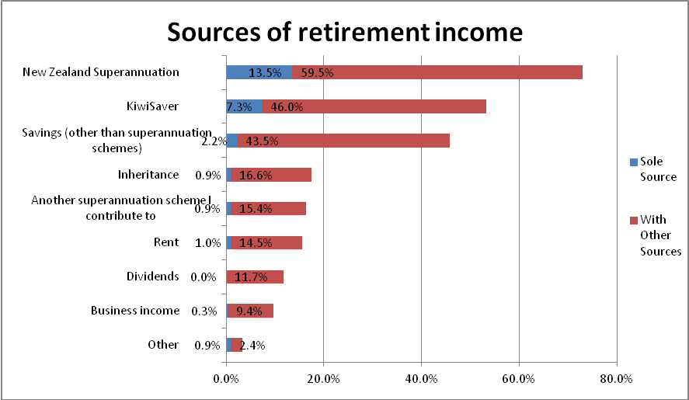

Funding New Zealand Superannuation

9.1 Ability to afford New Zealand Superannuation
Nearly 25% of respondents were not sure whether New Zealand could continue to afford New Zealand Superannuation if the age of eligibility remained at 65 years, but a majority, 58.4%, believed that it could not.

The higher their income, the less likely people are to believe that New Zealand Superannuation can be afforded.

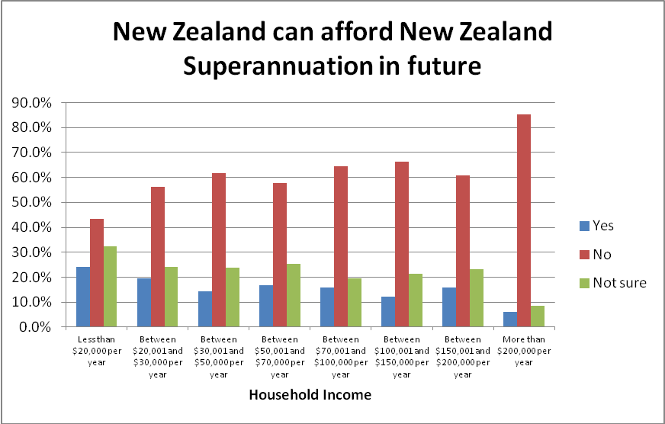

KiwiSaver members are more likely than non-members to believe that New Zealand Superannuation is unaffordable. They share this opinion with 18 to 24 year olds, who have a strong view that New Zealand Superannuation will not be affordable, and also with those who are at retirement age or older.

Even though those who see it as affordable are in the minority, 25 to 34 year olds, 55 to 64 year olds and those 75 years or more are the most likely to believe that it can be afforded.

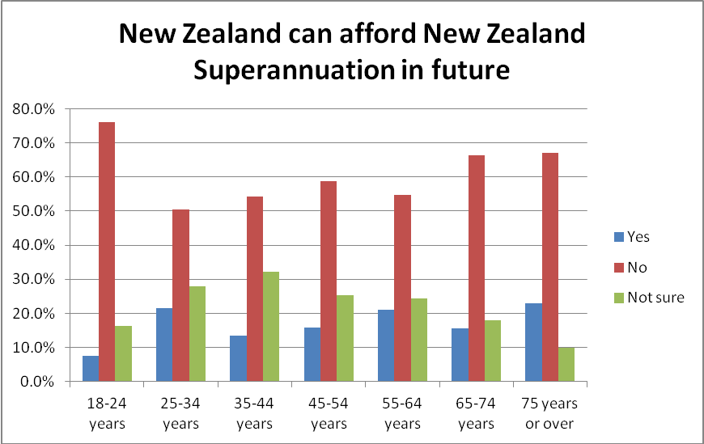

Illustrative reasons from people who think that New Zealand can afford New Zealand Superannuation in the future were:

“Affordability is a matter of priorities. I believe that the ability for everyone to live comfortably should be a priority for government.” (Respondent 25 to 34 years)

“Because it depends on other choices we / Government make. For e.g. tax rates, amount of $$ put into other areas. It's not just demographics.” (Respondent 35 to 44 years)

“Because it is simply a matter of priorities for the government, we could afford to pay a high share of our GDP to pension schemes as they do in Northern Europe if we had tax levels like those in northern Europe.” (Respondent 25 to 34 years)

“As a maturing society, we will have to afford the care of the elderly whatever it takes. We cannot just let the older people sicken and die...fact. There is a huge potential in the area of health care, residential care etc. for people to turn into industries to provide for the elderly population. Even builders will benefit by providing suitable retirement villages etc. I fear that a lot of this "we can't afford the elderly" is scaremongering by groups with vested interest in accessing peoples unsecured savings through KiwiSaver etc., putting pressure on the govt to make KiwiSaver compulsory. When I was working I could not have afforded to save weekly on my poor wage, so I think that betterpaid and more plentiful employment opportunities is the answer to all this.” (Respondent 55 to 64 years)

“It’s not a matter of ability it's a matter of priority. If we want to we can pay a universal pension from 65 to all New Zealanders. But that is money not spent on Education, Health, Job Creation etc. personally I would like to see some reform of State Super and might expect it to be less generous, but I think we should keep it as a safety net to prevent poverty amongst older people who have had bad luck without being so generous that it rewards people who have made bad choices about work/savings.”(Respondent 25 to 34 years)

“Because financial conditions change all the time and there's no point in being pessimistic when the future is uncertain.” (Respondent 55 to 64 years)

“Because many/most people will continue to work after this age either full or part time.” (Respondent 35 to 44 years)

“Because most baby boomers (which is me) will still be working long after they turn 65 FROM CHOICE ........ I WANT TO CONTINUE WORKING FOR MYSELF AS A CONTRACTOR for as long as I can healthily do so. I LOVE my jobs and have no intention of stopping.” (Respondent 55 to 64 years)

“Because the people pay their taxes, I feel this is a saving towards their retirement. If not all, it should be a big part. Is that not why we pay taxes?” (Respondent 45 to 54 years)

“By the time I get to that point I'm banking on the fact that we will be in a far better financial position as a country.” (Respondent 25 to 34 years)

“Hoping that the government will value our elderly people, their long standing commitment to work, getting to retirement, of family, and promote health when so vulnerable. Hopefully the govt. will prioritize values on people instead of things.” (Respondent 45 to 54 years)

“I think it is up to the government to make sure there are taxes or govt savings to be able to do so. We pay taxes and I really believe that people on an unemployment benefit should be told they will be penalised for time spent being too selective about getting work and not paying taxes will have a reduced retirement fund. More funds in the kitty and youth pregnancy should be treated the same way. There are plenty of ways to prevent it and the parents should have to be responsible for their teenagers and either the parents or the mother/father provides not the govt for the welfare of single parents unless of course through death of one of the parents. My husband paid child support all the way through until his daughter turned 19 and so should everyone. I HATE bludgers. I have had to work all my life except for a year when I was getting over the death of my first husband and had an 11 yr old.” (Respondent 55 to 64 years)

New Zealand has an obligation to support its old people. By the time I retire, if I make it, I will have worked and paid taxes for 47 years. If Taxes need to be higher and Government needs to cut its spending or use more imaginative, productive ways to find the money to support its elderly - so be it. ” (Respondent 45 to 54 years)

“It's a question of fairness. All our working life we were working in expectation that we would get the pension at age 60. I missed out by one year, I think, and have had to wait another 3 years. That has cost me $65,000.00 in lost savings I was expecting. Some people are totally worn out by age 60 and will struggle to get to 65. I was just made redundant last month and that has suddenly changed my retirement factors. An inheritance is only likely to come when my father dies. That should be sufficient. He is 89 but may live another 5 years. This means my wife or my wife and I will probably have to work that additional 5 years. This takes a job out of someone else's hands.”(Respondent 55 to 64 years)

“It’s not exactly hard -just depends on who's in government.”(Respondent 18 to 24 years)

People who think that New Zealand cannot afford New Zealand Superannuation in the future had quite different views:

“Too many old bastards in the baby boomer generation. And the baby boomer is front loading their entitlements, i.e.: committing and making sure they have their entitlements sorted. Which my generation will have to pay for.”(Respondent 25 to 34 years)

“1: GDP is not increasing fast enough to cope
2 - As we allow immigrants to import their families including parents we are burdened with additional costs NOT paid for in their taxes had they been resident from an early age and worked in New Zealand for the entirety of their working lives.”(Respondent 45 to 54 years)

“1: Because at present taxation rates, people on high incomes don't pay enough tax
2: No Capital gains tax
3: People on low wages or benefits cannot save anything for retirement.”(Respondent 75 years or over)

“A big increase in the number of people in retirement. This also means that a greater number of people experiencing health problems. Allowing for this, and considering the financial commitments that the government has - the funding just will not be there. Unless the government is in financial surplus - and this is doubtful.”(Respondent 65 to 74 years)

“A significant percentage of the wealth base both public and private has been lost due to freemarket experiments of the 1980s and 1990s and inadequate controls on the activities of the finance sector. The population is aging. Many of the higher earning younger generation are paying taxes to foreign governments.”(Respondent 45 to 54 years)

“As the Baby Boomer generation retires - these numbers will grow dramatically over the next 20 years, it will become too expensive to maintain this level of retirement at 65 - so even though we have paid taxes all our lives, we will miss out. They say a generation misses out for the sake of the next.”(Respondent 55 to 64 years)

“Baby boomers expecting all costs to be paid by the younger generation.”(Respondent 18 to 24 years)

Because if there are more people in retirement than those working (and hence paying taxes) then clearly there will be a shortfall in how much the country spends on Superannuation and how much it receives from taxes. Extra taxation on the workers will cripple the country!”(Respondent 18 to 24 years)

“Because people are trending to live longer, but the current working generation are struggling to provide for themselves let alone another generation - and with technology constantly evolving meaning fewer people are required to do manual work each generation is going to find employment difficult. This will lead to a bigger strain on Government funded super funds in the future.”(Respondent 25 to 34 years)

“Because there are far too many older people becoming retirement age each year. The government is in heavy debt already so where are they going to get the money from to continue paying us oldies let alone increase our benefit. The future for the elderly does not look good.”(Respondent 65 to 74 years)

“We already can't afford it at its current levels in my opinion. The age of eligibility needs to immediately rise to 70, and anyone under the age of 45 currently should be told they will only get 50% of the current entitlement when they retire. Also super should be taxed at the highest tax rate, to encourage people to get other sources of retirement income.”(Respondent 25 to 34 years)

We are a small population, and a fiercely independent people, taxes would need to rise in order to pay for superannuation, and I don't think younger NZer's would want to 'wear it' for the older generation. (And perhaps they shouldn't have to) the problem is, most of us live in the 'now' and don't plan ahead enough.”(Respondent 45 to 54 years)

9.2 Taxpayer willingness to fund New Zealand Superannuation
Respondents were asked for their view on whether taxpayers will be willing to pay for New Zealand Superannuation if the age of eligibility remains at 65 into the future.

Opinion was much more split on this question: a third of respondents said “No”; nearly a third said “Yes” and just over a third were not sure.

18 to 24 year olds were the most negative about this – 50% believed that taxpayers would not be willing to pay for New Zealand Superannuation.

Typical comments from the younger groups are:

“If all New Zealanders were aware that the number of elderly qualifying for superannuation was increasing, and that tax rates would have to increase to compensate for the deficit, I think they would think twice about saving for their own retirements instead of relying on a source that, (I hate to say it), can be unreliable. Not many people I know could afford the recent tax hikes, let alone a further 4-6% increase on top. It’s not right to pass the problem down to the next generation it just makes matters worse.”(Respondent 18 to 24 years)

“My generation will eventually rebel and there are just not enough of us to pay the burden the baby boomer generation is putting on us.”(Respondent 25 to 34 years)

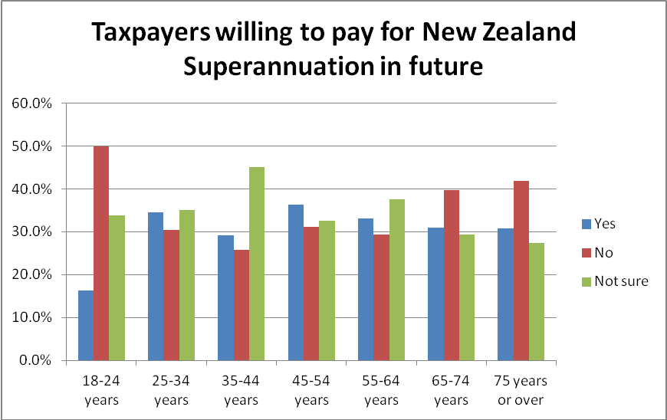

Other illustrative comments from those who did not believe that taxpayers would be willing to fund New Zealand Superannuation are:

“The sense of entitlement of the younger generations dictates that they would be unwilling to support those who are retired. Despite the fact that it was the retirees who created the businesses and the economy into which the younger generations have employed.”(Respondent 35 to 44 years)

“Because people are greedy.”(Respondent 18 to 24 years)

“The cost will be too much, the country will either go into debt to pay this or all taxes will have to increase.”(Respondent 45 to 54 years)

“Because people seem to only what to look after No 1 and don't think too much about the future.”(Respondent 35 to 44 years)

“Everything is getting too expensive; we don’t need any more costs. Those who have been on a benefit most of their lives shouldn’t be getting anything (other than sickness), those who have money in their bank I wouldn’t think qualify anyway (I don’t know much about this) yet I think that is unfair because they have made an effort. WeSHOULD be taking care of it ourselves.”(Respondent 25 to 34 years)

“The right wing parties have created this meme of individual responsibility for everything. They have framed taxation as evil and the left have not articulated that taxes actually pay for services. Until the left can teach the reality of taxes = better services then NZers will not be willing to pay more tax.”(Respondent 25 to 34 years)

“Govt fosters a climate of mistrust - dob in dole bludgers - subtle, snide comments, undermine society - why should I pay for the man next door who has never worked, (and to top it off he is an educated -university trained - skiver) everybody knows somebody like this.”(Respondent 55 to 64 years)

“All other countries are moving the retirement age up. 40 years ago you were very old at 65 - now people are not and have better health (if they don't eat crap food / junk food etc., etc.). Why should people work longer? Most people don't plan a retirement it happens and they get bored and moving from 65 people need to wean themselves into other activities / jobs / whatever. Get off their backsides and do something - don't expect hand-out just because you are 65.”(Respondent 45 to 54 years)

“In the current economic climate, people are reluctant to pay more tax, especially to fund a bottom-less pit.”(Respondent 35 to 44 years)

Illustrative comments from those who believe that taxpayers will be willing to fund New Zealand Superannuation are:

“Because, if you have common sense, the people currently working pay for the retirees, and eventually, the people currently working will be the retirees - what goes around, comes around. The logic is that of "your parents cared for you when you were born and a child, so it is now your turn to take care of them.”(Respondent 25 to 34 years)

“65 years of age is a reasonable age to retire, taxpayers would support this as they would in majority feel the same. ( that they themselves would like to retire by 65years of age) if someone chooses to continue working in a job over 65 years of age, depending on their income, they should not be entitled to all of the superannuation benefit.”(Respondent 35 to 44 years)

As workers we have paid our fair share of taxes and I feel that the elderly deserve to be looked after.”(Respondent 25 to 34 years)

“At least I hope so. Some of us have worked our whole lives, contributing to the coffers as we go. Only fair we have our turn to take it easy in retirement.”(Respondent 45 to 54 years)

“Why shouldn't they? Current and imminent superannuitants have contributed taxation all their lives in the expectation that one day they would be a recipient. Why should these people be cut out of a pension at a time of their life when they lack the ability to generate an income from other mean? Why not cut the dole or DPB from those who pay no tax but have the ability to do so?”(Respondent 55 to 64 years)

“If immigrants, residents and rich people continue to work and contribute to New Zealand tax there will be far more tax collected so there won't be any need to raise taxes and people will still be paying same taxes and they will be willing to pay.”(Respondent 25 to 34 years)

“With the right education on this topic, people would start contributing from young age in order to provide themselves with comfortable retirement.”(Respondent 18 to 24 years)

“Because everyone thinks they will qualify for universal superannuation so all will benefit from it in the future. The one constant as you cannot rely on investments as an individual.”(Respondent 55 to 64 years)

Ability to cover retirement expenses
Respondents were asked whether their current retirement income plan would cover 6 key expenditure events. Most people did not think that it would recover refurbishment of their house, 3 car replacements or taking an overseas holiday. However, they did generally think that it would allow visits to friends and relatives, to entertain them and to buy occasional luxuries and gifts.

The relative percentages are shown in the following table:

Current savings and retirement income plan sufficient to cover | Refurbish house after 30 to 40 years | Possibly renew car three times | Allow me to vFSCt friends and relatives | Take overseas holidays | Entertain family and/or friends | Afford occasional luxuries and gifts
Yes | 7.2% | 8.8% | 47.8% | 18.0% | 49.9% | 42.7%
No | 57.3% | 58.2% | 22.6% | 47.5% | 21.4% | 25.6%
Not sure | 24.0% | 24.7% | 25.6% | 29.0% | 24.5% | 27.6%
Does not apply to me | 11.5% | 8.3% | 4.0% | 5.5% | 4.2% | 4.1%

Respondent reaction to home refurbishment and vehicle replacement
Only a quarter of respondents were not surprised that the trend to living longer might mean that they needed to completely refurbish their home during their retirement and replace their vehicle three times; the rest were at least a little surprised.

Surprised or not surprised at needing to totally refurbish home and replace vehicle three times after retiring at 65 years old | Total
Very surprised | 17.3%
Surprised | 26.6%
A little surprised | 31.2%
Not surprised at all | 24.9%

The people who were very surprised were more likely to be women, to be aged from 25 to 54 years and to have few or no formal school qualifications.

Respondents were also asked if they had any comments on this. Illustrative comments are:

A good home should not need to be 'totally' refurbished and why would it be necessary to replace your car 3 times.”(Respondent 45 to 54 years)

“Damn! It's not just the refurbishing the home and new cars there's also replacement specs and hearing aids to consider as neither of these last too well.”(Respondent 55 to 64 years)

“For me house refurbishment isn't something that would be undertaken all at once. I wouldn't replace my car with a brand-new one either.”(Respondent 35 to 44 years)

“Have to rethink my plan or sell my house.”(Respondent 55 to 64 years)

“I believe the manufacturing of statistics that suggest people are living that much longer and require refurbishment on their homes and replacing their cars are extremely exaggerated to scare people and are designed to relief government from their prime duties of looking after their citizens.”(Respondent 45 to 54 years)

“I don't believe a home has to be refurnished to still be a happy home and I see no need to replace my car 3x. I have always bought 2nd hand cars (cheap) and don't see a new car as being necessary or desirable. There is more to life than material things.”(Respondent 55 to 64 years)

And two final comments from younger respondents:

“Crazy to think I’m gonna be spending 30-40 years mowing the lawns, clearing the yard, playing golf... stuff that.”(Respondent 18 to 24 years)

“Have not really thought of the implications of living so long after retirement.”(Respondent 18 to 24 years)

Review for retirement income security

Review needed to provide retirement income security for New Zealanders | Total
Yes | 85.6%
No | 4.2%
Not sure | 9.7%

Support for a review is highest amongst those with household income over $100,000 per annum, and people 55 years of age or older. There is still strong interest amongst younger people, however.

Support for multi-party political discussions on retirement income stability
There was strong support for multi-party discussions, particularly from those aged 45 years or more and those with household income greater than $100,000 per annum.

Support for multi-party discussions | Total
Strongly support | 46.9%
Support | 33.3%
Neutral | 13.5%
Oppose | 1.2%
Strongly oppose | 0.7%
Don't know | 4.5%

Focus groups
Half of the respondents were interested in attending focus groups on future retirement policy options. .

Support for attending focus groups | Total
Yes | 49.8%
No | 50.2%

Interest in attending is highest amongst those approaching retirement in the next 10 to 20 years – currently aged 45 to 64 years of age – and those with household income of $50,000 per annum or more.The youngest age group, who strongly believe that New Zealand Superannuation cannot be afforded, are the least interested in attending.

APPENDIX 1 – SAMPLE

Sample
This survey is of 2558respondents who are members of Horizon Research’s HorizonPoll panel, which represents the New Zealand adult population. Post-sample iterative rim weighting was used to match population averages for age, gender, region, personal income, employment and education level.

The maximum margin of error at a 95% confidence level is ±2.1% overall.

Dates
Interviewing was undertaken between December 2 and 30, 2011.

Working/Non-working
The sample from this survey showed a working/non-working profile as follows:

In paid workforce | Total
Full time | 41.2%
Part time | 22.8%
Not in paid employment | 21.6%
Retired and 65 years of age or more (not doing any paid work at all) | 11.3%
Retired and under 65 years of age (not doing any paid work at all) | 3.1%

Living arrangements
The sample from this survey showed a living arrangement profile as follows:

Current living arrangements | Total | KiwiSaver member
 |  | Yes | No
Own dwelling with a mortgage | 31.1% | 32.4% | 29.8%
Own dwelling without a mortgage | 20.3% | 16.8% | 24.1%
Renting a dwelling | 31.1% | 33.6% | 28.0%
Flatting/boarding | 9.5% | 11.2% | 6.6%
In a dwelling owned by a family trust | 4.1% | 3.1% | 5.0%
With parents | 2.5% | 0.9% | 3.8%
Other | 1.4% | 1.3% | 1.7%

Analysis
All analysis shown in this report is taken from the weighted data.

Respondent comments
All verbatim comments from respondents are captured and available from the Horizon Research system.

Contact
For more information about this survey or additional analysis, please contact Grant McInman on 021 076 2040, email gmcinman@horizonresearch.co.nz.

APPENDIX 2 – PROFILES
APPENDIX 2 - PROFILES
Some of the comments in this report are based on profiles of respondents answering selected questions, which weresupplied to FSC in December 2011. The profile for those who thought they were personally responsible for their income in retirement follows. For other profiles, please refer to the information supplied in December 2011.
Q3. I believe I am personally responsible for my income security in retirement
 | This table shows a profile of the respondents who:
 | - | agreed or strongly agreed that they were personally responsible for their income security in retirement; AND
 | - | disagreed or strongly disagreed that the government was responsible for their income security in retirement; AND
 | - | disagreed or strongly disagreed that their family and others were responsible for their income security in retirement
 | Profile information from the total sample is shown in the "Total" column to highlight differences between the group who believe they are solely responsible for their income security in retirement and the population in general.
 | Where the differences are above the total sample by the margin of error or more, the percentages are shaded in green. Where they are below the total sample by the margin of error or more, the percentages are shaded in red.
 |  |  | Total sample | Solely responsible
 | Sex
 |  | Female | 50.9% | 52.6%
 |  | Male | 49.1% | 47.4%
 | Age Group
 |  | Under 18 years | 0.2% | 0.6%
 |  | 18-24 years | 9.5% | 12.9%
 |  | 25-34 years | 12.3% | 17.9%
 |  | 35-44 years | 15.8% | 17.7%
 |  | 45-54 years | 19.2% | 23.5%
 |  | 55-64 years | 23.2% | 13.3%
 |  | 65-74 years | 15.5% | 12.6%
 |  | 75 years or over | 4.3% | 1.4%
 | Household Income
 |  | Less than $20,000 per year | 13.0% | 10.7%
 |  | Between $20,001 and $30,000 per year | 14.1% | 10.0%
 |  | Between $30,001 and $50,000 per year | 20.9% | 21.7%
 |  | Between $50,001 and $70,000 per year | 13.7% | 14.5%
 |  | Between $70,001 and $100,000 per year | 13.5% | 17.3%
 |  | Between $100,001 and $150,000 per year | 8.9% | 10.7%
 |  | Between $150,001 and $200,000 per year | 2.2% | 2.9%
 |  | More than $200,000 per year | 1.1% | 2.2%
 |  | Don't know/ prefer not to say | 12.5% | 10.0%
 | Personal Income |  | Total sample | Solely responsible
 |  | Less than $20,000 per year | 38.7% | 37.6%
 |  | Between $20,001 and $30,000 per year | 14.0% | 11.5%
 |  | Between $30,001 and $50,000 per year | 21.2% | 24.1%
 |  | Between $50,001 and $70,000 per year | 9.1% | 9.7%
 |  | Between $70,001 and $100,000 per year | 4.8% | 6.0%
 |  | Between $100,001 and $150,000 per year | 1.9% | 3.0%
 |  | Between $150,001 and $200,000 per year | 0.1% | 0.2%
 |  | More than $200,000 per year | 0.3% | 0.7%
 |  | Don't know/ prefer not to say | 10.0% | 7.3%
 | Employed
 |  | Yes | 63.4% | 66.6%
 |  | No | 36.6% | 33.4% | ** Note: Those who say that they are not employed includes those who are unemployed or on a benefit, those who are retired or homemakers, as well as some students.
 | Household Type
 |  | Couple only (no children/none at home) | 30.7% | 29.9%
 |  | Extended family | 3.9% | 3.8%
 |  | Flatting or boarding - not a family home | 6.7% | 7.0%
 |  | One parent family, one or two children at home | 5.3% | 3.8%
 |  | One parent family, three or more children at home | 2.0% | 4.3%
 |  | Single person household | 16.4% | 14.5%
 |  | Two parent family, one or two children at home | 22.9% | 23.3%
 |  | Two parent family, three or more children at home | 9.0% | 11.2%
 |  | Prefer not to say | 3.1% | 2.4%
 |  |  | Total sample | Solely responsible
 | Occupation
 |  | Business Manager/Executive | 5.6% | 7.8%
 |  | Business Proprietor/Self-employed | 5.6% | 6.5%
 |  | Clerical/Sales Employee | 14.2% | 15.7%
 |  | Farm Owner/manager | 0.5% | 0.5%
 |  | Labourer/Agricultural or Domestic Worker | 5.6% | 6.4%
 |  | Professional/Senior Government Official | 4.2% | 4.0%
 |  | Student | 9.7% | 9.2%
 |  | Teacher/Nurse/Police or other trained service worker | 7.6% | 6.1%
 |  | Technical/mechanical/Skilled Worker | 8.7% | 9.8%
 |  | Don't know/prefer not to say | 6.4% | 4.9%
 |  | Home-maker (not otherwise employed) | 8.1% | 9.7%
 |  | Retired/Superannuitant | 15.2% | 13.8%
 |  | Unemployed/Beneficiary | 8.7% | 5.6%
 | Highest Qualification
 |  | No formal school qualification | 17.2% | 15.5%
 |  | NCEA Level 1 or School Certificate | 19.1% | 19.8%
 |  | Sixth form/UE/NCEA Level 2 | 21.7% | 25.6%
 |  | University Bursary or 7th form | 5.4% | 6.2%
 |  | Vocational qualification (includes trade certificates, diplomas etc.) | 12.7% | 11.7%
 |  | Undergraduate (Bachelor) degree | 11.0% | 10.4%
 |  | Postgraduate degree (Masters' degree or PhD) | 3.2% | 2.9%
 |  | Prefer not to say | 10.0% | 8.0%
 |  |  | Total sample | Solely responsible
 | Region or City
 |  | Northland | 4.2% | 4.1%
 |  | Auckland | 29.9% | 29.6%
 |  | Hamilton | 2.8% | 3.0%
 |  | Waikato/Coromandel | 4.7% | 4.2%
 |  | Tauranga | 3.0% | 3.0%
 |  | Bay of Plenty | 2.7% | 2.4%
 |  | Central Plateau | 0.8% | 1.2%
 |  | Taranaki | 2.1% | 1.9%
 |  | Manawatu/Horowhenua/Wanganui | 4.4% | 5.0%
 |  | Palmerston North | 1.8% | 1.9%
 |  | East Coast | 1.3% | 1.8%
 |  | Hawkes Bay | 4.3% | 4.5%
 |  | Wairarapa | 1.5% | 1.7%
 |  | Wellington/Kapiti | 12.4% | 13.5%
 |  | Nelson/Marlborough | 3.0% | 2.5%
 |  | Canterbury | 5.1% | 4.4%
 |  | Christchurch | 8.8% | 9.3%
 |  | Westland | 0.3% | 0.2%
 |  | Dunedin | 4.1% | 2.5%
 |  | Otago/Lakes | 1.6% | 2.5%
 |  | Invercargill | 0.7% | 0.6%
 |  | Southland | 0.7% | 0.2%

APPENDIX 3 – COMPARISON BETWEEN SUPPLIED LONGEVITY TABLES AND SURVEY
Comparison graphs in Appendix 3 show the percentage of people who have attained 65 years and expected to be still alive in subsequent age groupings. These graphs are based on both the tables supplied and the survey.

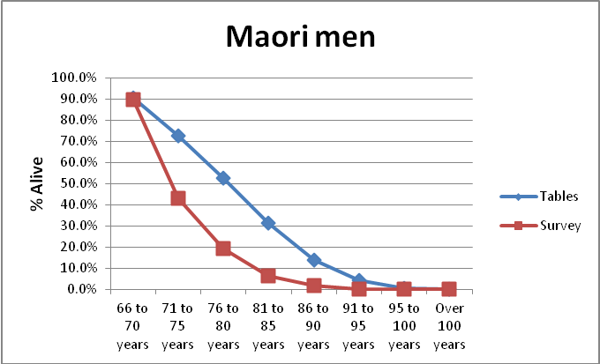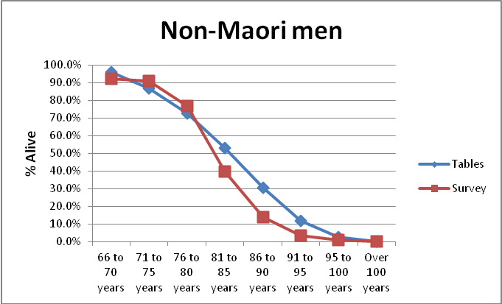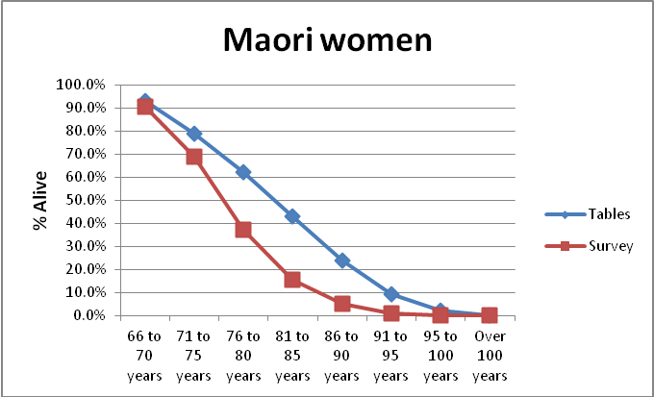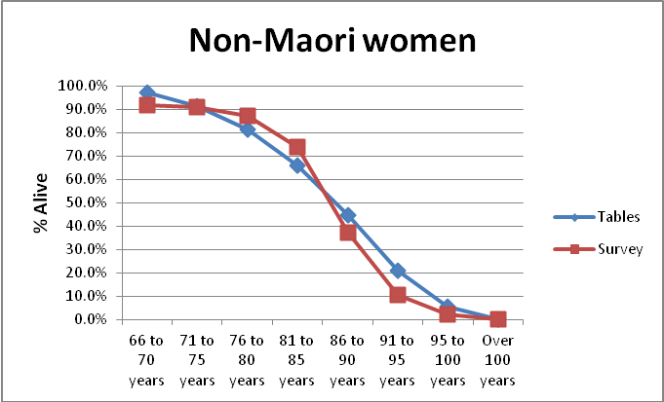

APPENDIX 4 –QUESTIONNAIRE

Questionnaire
Firstly, some information about you....
 | 1. Are you currently in the paid work force?
 | A. | Full time
 | B. | Part time
 | C. | Not in paid employment
 | D. | Retired and 65 years of age or more (not doing any paid work at all)
 | E. | Retired and under 65 years of age (not doing any paid work at all)
 | 2. Which of the following best describes where you live?
 | A. | Own dwelling with a mortgage
 | B. | Own dwelling without a mortgage
 | C. | Renting a dwelling
 | D. | Flatting/boarding
 | E. | In a dwelling owned by a family trust
 | F. | Other (please specify)
 | 2.1. Do you expect to own your own dwelling without a mortgage by the time you retire?
 | A. | Yes
 | B. | No
 | C. | Already retired and own a dwelling without a mortgage
 | D. | Not sure
 | People have given us a number of statements related to savings and their finances. Please tell us how strongly you personally agree or disagree with each of these statements.
 | 3. I believe I am personally responsible for my income security in retirement
 | A. | Strongly agree
 | B. | Agree
 | C. | Disagree
 | D. | Strongly disagree
 | 3.1. The government is responsible for my income security in retirement
 | A. | Strongly agree
 | B. | Agree
 | C. | Disagree
 | D. | Strongly disagree
 | 3.2. My family and others are responsible for my income security in retirement
 | A. | Strongly agree
 | B. | Agree
 | C. | Disagree
 | D. | Strongly disagree
 | 3.3. I know how much money I need for my retirement
 | A. | Strongly agree
 | B. | Agree
 | C. | Disagree
 | D. | Strongly disagree
 | 3.4. I am not really planning for my retirement
 | A. | Strongly agree
 | B. | Agree
 | C. | Disagree
 | D. | Strongly disagree
 | 3.5. I often find it hard to live on my current income
 | A. | Strongly agree
 | B. | Agree
 | C. | Disagree
 | D. | Strongly disagree
 | 3.6. KiwiSaver will provide its members with an adequate retirement income
 | A. | Strongly agree
 | B. | Agree
 | C. | Disagree
 | D. | Strongly disagree
 | 3.7. New Zealand Superannuation will cover my retirement income needs
 | A. | Strongly agree
 | B. | Agree
 | C. | Disagree
 | D. | Strongly disagree
 | 4. Are you personally a member of KiwiSaver?
 | A. | Yes
 | B. | No
 | 4.1. Is someone else in your family or household a member of KiwiSaver?
 | A. | Yes
 | B. | No
 | C. | I really don't know
 | If you had $1000 in a bank account paying 3% interest a year (after tax and fees), how long do you think it would take to double the value to $2000, if you leave all the interest earned in the account?
 | 5.1. 3% net after tax and fees
 | Results for 2463 total responses (format: Dropbox)
 | A. | 10 years
 | B. | 11 years
 | C. | 12 years
 | D. | 14 years
 | E. | 15 years
 | F. | 16 years
 | G. | 17 years
 | H. | 18 years
 | I. | 19 years
 | J. | 20 years
 | K. | 21 years
 | L. | 22 years
 | M. | 23 years
 | N. | 24 years
 | O. | 25 years
 | P. | 26 years
 | Q. | 27 years
 | R. | 28 years
 | S. | 29 years
 | T. | 30 years
Retirement and Lifespan
 | 6. At what age do you think you will retire (completely stop paid work)?
 | A. | Under 60 years
 | B. | At 60 years
 | C. | At 61 years
 | D. | At 62 years
 | E. | At 63 years
 | F. | At 64 years
 | G. | At 65 years
 | H. | At 66 years
 | I. | At 67 years
 | J. | At 68 years
 | K. | At 69 years
 | L. | At 70 years
 | M. | At 71 years
 | N. | At 72 years
 | O. | At 73 years
 | P. | At 74 years
 | Q. | At 75 years
 | R. | At 76 years
 | S. | At 77 years
 | T. | At 78 years
 | U. | At 79 years
 | V. | At 80 years
 | W. | Over 80 years
 | 7. Thinking about yourself only, if you live to, or are already aged 65 or older, to what age to you expect to live?
 | A. | 65 to 70 years
 | B. | 71 to 75 years
 | C. | 76 to 80 years
 | D. | 81 to 85 years
 | E. | 86 to 89 years
 | F. | 91 to 95 years
 | G. | 96 to 100 years
 | H. | Over 100 years
 | I. | Don't know
 | On average, to which one of the following age ranges do you think New Zealanders now live after they get to 65 years?
 | Please select one answer for each gender
 | 8.1. Maori Men
 | A. | 66 to 70 years
 | B. | 71 to 75 years
 | C. | 76 to 80 years
 | D. | 81 to 85 years
 | E. | 86 to 90 years
 | F. | 91 to 95 years
 | G. | 95 to 100 years
 | H. | Over 100 years
 | I. | Don't know
 | 8.2. Non Maori Men
 | A. | 66 to 70 years
 | B. | 71 to 75 years
 | C. | 76 to 80 years
 | D. | 81 to 85 years
 | E. | 86 to 90 years
 | F. | 91 to 95 years
 | G. | 95 to 100 years
 | H. | Over 100 years
 | I. | Don't know
 | 8.3. Maori Women
 | A. | 66 to 70 years
 | B. | 71 to 75 years
 | C. | 76 to 80 years
 | D. | 81 to 85 years
 | E. | 86 to 90 years
 | F. | 91 to 95 years
 | G. | 95 to 100 years
 | H. | Over 100 years
 | I. | Don't know
 | 8.4. Non Maori Women
 | A. | 66 to 70 years
 | B. | 71 to 75 years
 | C. | 76 to 80 years
 | D. | 81 to 85 years
 | E. | 86 to 90 years
 | F. | 91 to 95 years
 | G. | 95 to 100 years
 | H. | Over 100 years
 | I. | Don't know
 | Thinking ahead now, on average to which age will New Zealanders who turn age 65 in the year 2061 eventually live to?
 | Please select an answer for each gender
 | 9. Maori Men
 | A. | 65 to 70 years
 | B. | 71 to 75 years
 | C. | 76 to 80 years
 | D. | 81 to 85 years
 | E. | 86 to 90 years
 | F. | 91 to 95 years
 | G. | 96 to 100 years
 | H. | Over 100 years
 | I. | Don't know
 | 9.1. Non Maori Men
 | A. | 65 to 70 years
 | B. | 71 to 75 years
 | C. | 76 to 80 years
 | D. | 81 to 85 years
 | E. | 86 to 90 years
 | F. | 91 to 95 years
 | G. | 96 to 100 years
 | H. | Over 100 years
 | I. | Don't know
 | 9.2. Maori Women
 | A. | 65 to 70 years
 | B. | 71 to 75 years
 | C. | 76 to 80 years
 | D. | 81 to 85 years
 | E. | 86 to 90 years
 | F. | 91 to 95 years
 | G. | 96 to 100 years
 | H. | Over 100 years
 | I. | Don't know
 | 9.3. Non Maori Women
 | A. | 65 to 70 years
 | B. | 71 to 75 years
 | C. | 76 to 80 years
 | D. | 81 to 85 years
 | E. | 86 to 90 years
 | F. | 91 to 95 years
 | G. | 96 to 100 years
 | H. | Over 100 years
 | I. | Don't know
 | Every 10 years, the number of people in New Zealand living to be older than 65 years rises. How much longer do you think people born in 2006 can expect to live than people who were born in 1996?
 | Please tick one for each gender
 | 10.1. Men
 | A. | 0.5 year
 | B. | 1 year
 | C. | 1.5 years
 | D. | 2 years
 | E. | 2.5 years
 | F. | 3 years
 | G. | 3.5 years
 | H. | 4 years
 | I. | 4.5 years
 | J. | 5 years
 | K. | More than 5 years
 | L. | Not sure
 | 10.2. Women
 | A. | 0.5 year
 | B. | 1 year
 | C. | 1.5 years
 | D. | 2 years
 | E. | 2.5 years
 | F. | 3 years
 | G. | 3.5 years
 | H. | 4 years
 | I. | 4.5 years
 | J. | 5 years
 | K. | More than 5 years
 | L. | Not sure
Retirement income
To help you answer some of the next few questions here are some examples of what people on New Zealand Superannuation retirement benefit get paid weekly and per year.
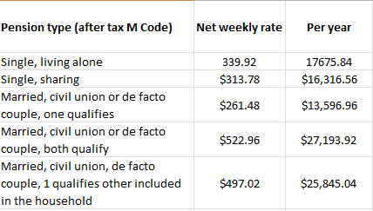

 | What level of weekly income after tax do you think you will need to live comfortably in retirement?
 | 11.1. A couple
 | A. | $300 to $400
 | B. | $401 to $500
 | C. | $501 to $550
 | D. | $551 to $600
 | E. | $601 to $800
 | F. | $801 to $1000
 | G. | $1001 to $1500
 | H. | $1500 to $2000
 | I. | More than $2000
 | 11.2. Single person
 | A. | $300 to $400
 | B. | $401 to $500
 | C. | $501 to $550
 | D. | $551 to $600
 | E. | $601 to $800
 | F. | $801 to $1000
 | G. | $1001 to $1500
 | H. | $1500 to $2000
 | I. | More than $2000
 | 12. Do you believe you will have enough income in retirement to cover your basic costs for food, accommodation and health care?
 | A. | Yes
 | B. | No
 | C. | Not sure
 | 13. Do you believe you can live comfortably in retirement on a government pension, like New Zealand Superannuation, as your only source of income?
 | A. | Yes - no other income needed
 | B. | No
 | C. | Don't know
 | 14. Do you think you are currently saving enough to retire on a comfortable income?
 | A. | Yes
 | B. | No
 | C. | Don't know
 | 15. Do you have an adequate income to live on in retirement?
 | A. | More than adequate
 | B. | Adequate
 | C. | Slightly less than adequate
 | D. | Inadequate
 | E. | Totally inadequate
 | 16. How concerned are you that the retirement savings you have, or hope to have, will run out before the end of your life?
 | A. | Very concerned
 | B. | Concerned
 | C. | Concerned a little
 | D. | Not much concerned
 | E. | Not concerned at all
 | 16.1. If you are retired, is your current income as much as you expected before you retired?
 | A. | Yes
 | B. | No
 | C. | I am not retired, does not apply to me
 | D. | Do you have any comments on this?
 | 17. Which of these sources of income do you have, or will you expect to have, to provide income during your retirement?
 | Please tick all that apply
 | A. | New Zealand Superannuation
 | B. | KiwiSaver
 | C. | Another superannuation scheme I contribute to
 | D. | Savings (other than superannuation schemes)
 | E. | Business income
 | F. | Dividends
 | G. | Rent
 | H. | Inheritance
 | I. | Other (please specify)
Funding retirement
To help you answer the next few questions, here is some background for you
In New Zealand there are more older people and they are living longer.
The "baby boomers" (born between 1946 and the early 1960s) are beginning to become eligible for New Zealand Superannuation.
The number of people eligible for New Zealand Superannuation will be increasing faster than the number in employment.
Based on current trends, almost half of those born in 2011 will live to more than 100 years-old.
This suggests if we retire at 65 many people will live longer in retirement than the number of years they were in employment, although some continue to work after they receive New Zealand Superannuation.
The cost of the current New Zealand Superannuation scheme will go from 5 to 6% of gross domestic product to closer to 10%.
Without any other changes, to pay for this the standard income tax rate of 17.5% will need to rise to 20.5% (up 3%) and the GST rate will need to rise from 15% to 18.5%.
 | 18. If the age at which people receive New Zealand Superannuation remains at 65 into the future, do you think New Zealand will be able to afford New Zealand Superannuation?
 | A. | Yes
 | B. | No
 | C. | Not sure
 | 19.1. You said that you thought New Zealand will be able to afford New Zealand Superannuation in the future. Why do you say that?
 | 19.2. You said that you thought New Zealand will not be able to afford New Zealand Superannuation in the future. Why do you say that?
Retirement lifestyles
 | 20. If the age at which people receive New Zealand Superannuation remains at 65 into the future, do you think taxpayers will be willing to pay for New Zealand Superannuation?
 | A. | Yes
 | B. | No
 | C. | Not sure
 | 21.1. You said that you thought New Zealand taxpayers will be willing to pay for New Zealand Superannuation in the future. Why do you say that?
 | 21.2. You said that you thought New Zealand taxpayers will not be willing to pay for New Zealand Superannuation in the future. Why do you say that?
 | If you were to live 30 to 40 years in retirement, as the current population trends suggest, would your current savings and retirement income plan cover the following?
 | 22. Refurbish house after 30 to 40 years
 | A. | Yes
 | B. | No
 | C. | Not sure
 | D. | Does not apply to me
 | 22.1. Possibly renew car three times
 | A. | Yes
 | B. | No
 | C. | Not sure
 | D. | Does not apply to me
 | 22.2. Allow me to visit friends and relatives
 | A. | Yes
 | B. | No
 | C. | Not sure
 | D. | Does not apply to me
 | 22.3. Take overseas holidays
 | A. | Yes
 | B. | No
 | C. | Not sure
 | D. | Does not apply to me
 | 22.4. Entertain family and/or friends
 | A. | Yes
 | B. | No
 | C. | Not sure
 | D. | Does not apply to me
 | 22.5. Afford occasional luxuries and gifts
 | A. | Yes
 | B. | No
 | C. | Not sure
 | D. | Does not apply to me
 | 23. Are you surprised or not surprised that the trend to living longer could see those who are being born today needing to totally refurbish their home and replace their vehicle three times after retiring at 65 years old?
 | A. | Very surprised
 | B. | Surprised
 | C. | A little surprised
 | D. | Not surprised at all
 | 24. Do you have any comments about that?
 | 24.1. Overall, do you think New Zealand needs to review how it can provide retirement income security for New Zealanders into the future?
 | A. | Yes
 | B. | No
 | C. | Not sure
 | D. | Comment
 | 24.2. Would you support or oppose all of the political parties in Parliament joining in discussions on how New Zealand can provide retirement income security into the future?
 | A. | Strongly support
 | B. | Support
 | C. | Neutral
 | D. | Oppose
 | E. | Strongly oppose
 | F. | Don't know
 | 24.3. If focus groups were to be held in your area to discuss future retirement policy options, would you like us to invite you to attend?
 | A. | Yes
 | B. | No

